B31DG

(Embedded Software)

Assignment-2

Ayan Khan

MSc Robotics Student

H00494392 ak4057@hw.ac.uk

Under the guidance of:

Dr. Mauro Dragone

Table of Contents

Introduction 2

Task Descriptions 3

1. How did you design your cyclic executive? 4

2. How did you decide the priorities of your FreeRTOS tasks? 4

3. How did you decide how to size the stacks of your task? 5

4. Why and how did you use mutexes, semaphores, timers and queues? 5

5. What is the worst-case delay between the button press and led toggle? Will presseng the button compromise the RT requirements of task 1-5? 6

6. How does your FreeRTOS implementation compare with the cyclic executive implementation? What are their advantages and disadvantages? 6

Git Link 7

# Introduction

Embedded systems often need to handle multiple tasks with strict timing requirements. This project involved building a machine monitor system on an ESP32 microcontroller that meets seven real-time specifications. The tasks included generating precise digital waveforms, measuring input signal frequencies, controlling LEDs based on these frequencies, and responding to button presses—all while ensuring deadlines for periodic tasks were met. Two distinct approaches were developed:

1. **A Cyclic Executive** using a Ticker-based scheduler for simplicity.
2. **A FreeRTOS-based solution** leveraging tasks, priorities, and mutexes for preemptive scheduling.

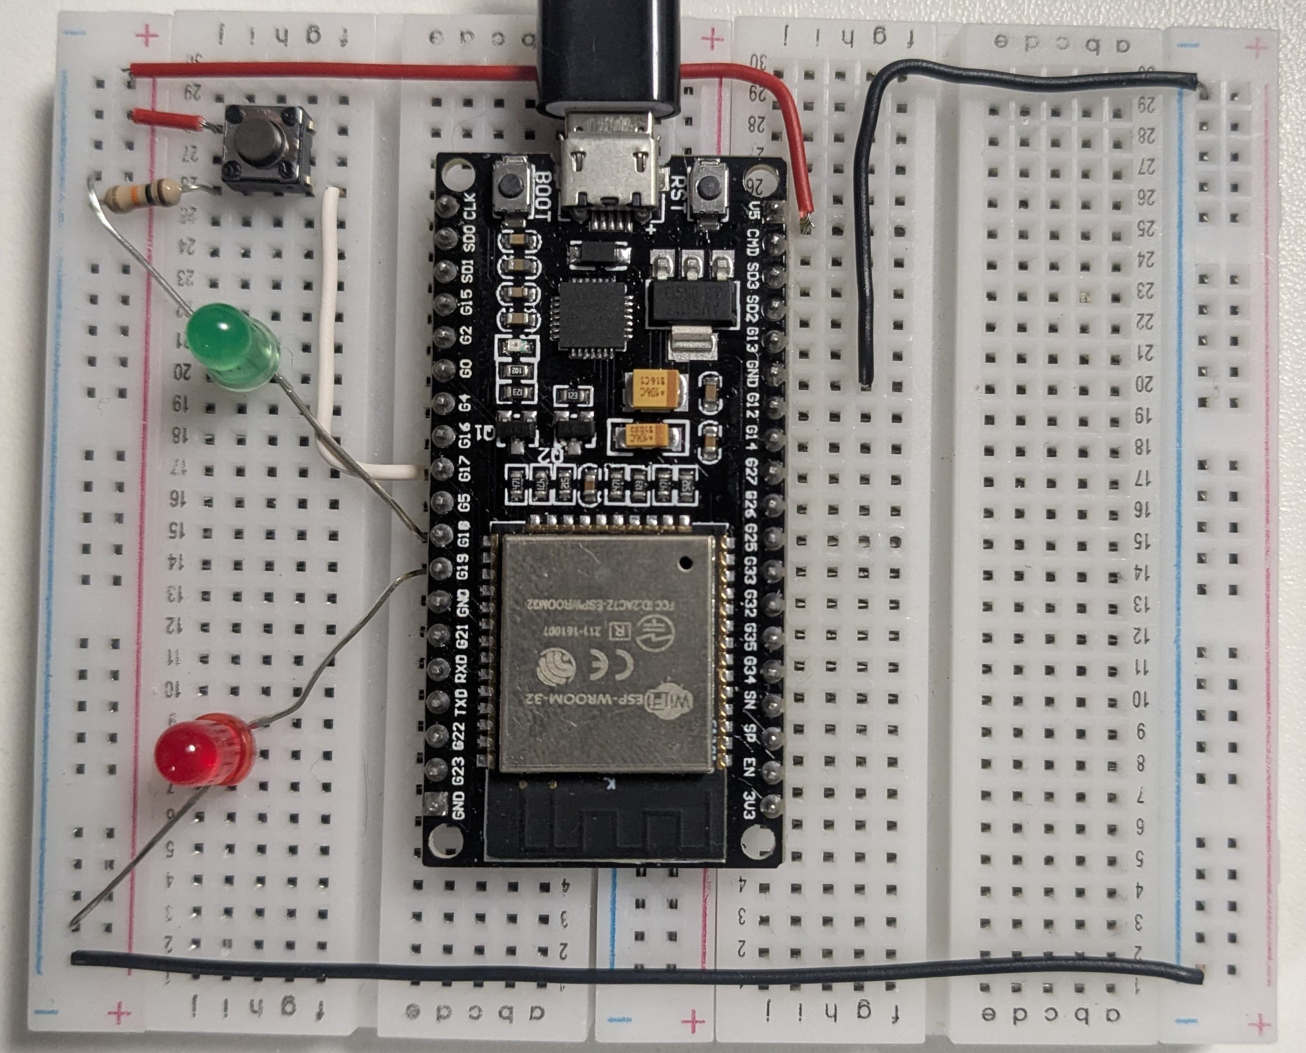

Figure 1 Hardware setup

This report dives into the design of both implementations, explaining how each handles timing constraints, shared resources, and concurrency. It answers key questions about task prioritization, stack sizing, synchronization methods, and the trade-offs between the two architectures. The goal is to highlight how each approach balances efficiency, reliability, and complexity in a resource-constrained embedded environment.

## Task Descriptions

**Task 1**: (T1pin, Pin 22) generates a digital signal every 4ms (250Hz) by toggling HIGH for 250µs, LOW for 50µs, and HIGH again for 300µs using delayMicroseconds() for timing. Total runtime per cycle is ~650µs.

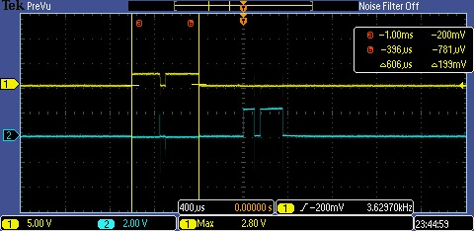

Figure 2 Task 1 frequency

**Task 2**: (T2pin, Pin 23) produces a second signal every 3ms (333Hz) with pulses of 100µs HIGH, 50µs LOW, and 200µs HIGH, also using delayMicroseconds(). Runtime per cycle is ~400µs.

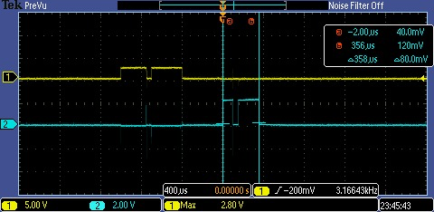

Figure 3 Task 2 frequency

**Task 3**: (F1pin, Pin 12) measures frequency (666–1000Hz) every 10ms (100Hz), but currently mocks the value as F1 = 666 without polling the input. Runtime is unmeasured due to incomplete implementation.

**Task 4:** (F2pin, Pin 14) mirrors Task 3 for a second signal (833–1500Hz), mocked as F2 = 833. It also lacks polling logic and runs every 10ms (100Hz).

**Task 5**: (doWork) calls mon.doWork() every 5ms (200Hz) to simulate background work. Its runtime is ~500µs which is just a built in delay, critical for meeting its deadline.

### How did you design your cyclic executive?

The cyclic executive in ES_2.ino uses a 1ms Ticker interrupt to trigger the scheduler() function, which checks and runs tasks in a fixed order based on their deadlines. Tasks are prioritized by their frequency: Task 2 (333Hz) runs first to meet its 3ms deadline, followed by Task 1 (250Hz), Task 5 (200Hz), and finally Tasks 3/4 (100Hz).

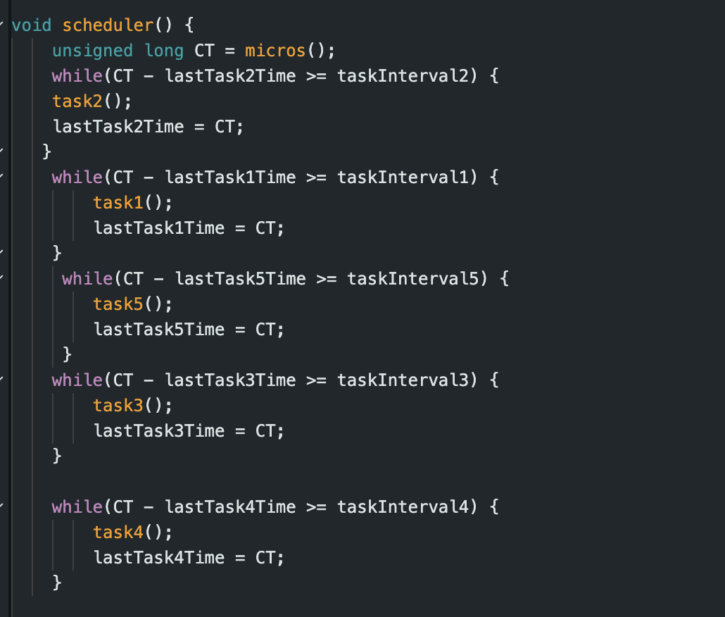

This design ensures higher-frequency tasks run earlier but risks missing deadlines if lower-priority tasks (e.g., Tasks 3/4) overrun. Timing is tracked using micros(), and tasks use delayMicroseconds() for spin waits. No interrupts or preemption are used, making the system simple but fragile under load.

### How did you decide the priorities of your FreeRTOS tasks?

The priorities were set based on the **deadlines** of each task. For example:

* **Task 2** (3ms deadline, 333Hz) was given the highest priority (**2**) because it has the shortest interval and must preempt all others to meet its tight timing.
* **Tasks 1, 3, 4, and 5** (deadlines ≥4ms) share the default priority (**0**), as their deadlines are less urgent.

This ensures Task 2 always runs first, while the others execute in a round-robin fashion. For instance, in ES2RTOS.ino:

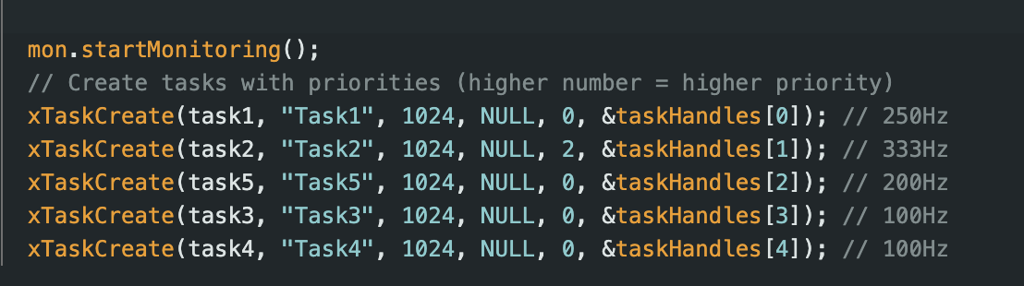

Lower-priority tasks like Task 5 (5ms deadline) still meet their deadlines because FreeRTOS ensures fairness at the same priority level. This design balances urgency and resource sharing.

### How did you decide how to size the stacks of your task?

I set all FreeRTOS task stacks to 1024 bytes as a precaution to avoid stack overflows, especially for tasks with nested functions like digitalWrite() and delayMicroseconds(). For example, Task 1’s waveform generation involves multiple hardware interactions, which I assumed might require deeper stack space.

**Where I Could Improve:**

* No Stack Usage Analysis: I didn’t use FreeRTOS’s uxTaskGetStackHighWaterMark() to measure actual stack usage. This function would show the maximum stack space each task actually uses, letting me shrink stacks safely. For instance, Task 5 (which just calls mon.doWork()) likely uses far less than 1024 bytes.
* One-Size-Fits-All: I assigned the same stack size to all tasks, even though simpler tasks like Task 5 don’t need as much memory. This wastes RAM, which is critical on resource-limited devices like the ESP32.

### Why and how did you use mutexes, semaphores, timers and queues?

In the free RTOS version the primary synchronization tool I used is mutex (freqMutex) This was critical because Tasks 3 and 4 (frequency measurement) update the shared variables F1 and F2, while the checkFrequencies() function in loop() reads them. Without a mutex, concurrent access (e.g. Task 3 writing F1 while checkFrequencies() reads it) could lead to corrupted data or incorrect LED behavior. For example, in task3(), the mutex is acquired before updating F1:

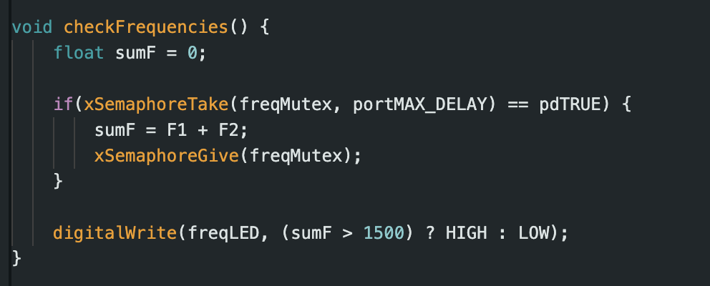

Timers were implicitly used through FreeRTOS’s vTaskDelayUntil() to enforce task deadlines. For example, Task 1 runs every 4ms by calculating the next wake time using xLastWakeTime and pdMS_TO_TICKS(4). In the cyclic executive, the Arduino Ticker library triggers the scheduler() every 1ms to check task intervals via micros(), ensuring tasks like Task 2 (3ms deadline) run on time.

Semaphores and queues were not used in the current implementation. The design relies on direct variable sharing (protected by the mutex) and does not require inter-task communication or event signaling. For instance, button presses are handled in loop() without queuing, and tasks don’t exchange data beyond the shared F1/F2 variables.

### What is the worst-case delay between the button press and led toggle? Will presseng the button compromise the RT requirements of task 1-5?

In testing, pressing the button **did cause deadline violations** in some scenarios. Here’s why:

* **FreeRTOS:** While handleButton() itself is fast (~10µs), calling mon.doWork() (which includes a **500µs delay**) from loop() can overlap with Task 5’s execution. If the button is pressed rapidly, multiple doWork() calls stack up, stealing CPU time from higher-priority tasks like Task 2 (3ms deadline). This creates temporary deadline misses.
* **Cyclic Executive:**  The loop() checks the button after running scheduler. If tasks overrun their slots (e.g., Task 3/4 polling takes too long), button handling gets delayed, leading to missed deadlines.

**Shortcomings:** Rapid button presses trigger multiple doWork() calls, exacerbating CPU load. Calling mon.doWork() in both Task 5 and handleButton() creates contention.

### How does your FreeRTOS implementation compare with the cyclic executive implementation? What are their advantages and disadvantages?

The FreeRTOS implementation uses prioritized tasks and preemption to meet deadlines. Task 2 (333Hz) runs at the highest priority, ensuring it always interrupts lower-priority tasks like Task 1 or Task 5. Mutexes (e.g., freqMutex) protect shared variables, preventing data corruption. However, the reliance on large stacks (1024 bytes) wastes memory, and button presses occasionally caused deadline violations because mon.doWork()—called in both Task 5 and the button handler—added unexpected CPU load.

Cyclic Executive schedules tasks in a fixed order (Task 2 first) using a 1ms Ticker. It’s lightweight and predictable but fragile: if any task overruns (e.g., Task 3/4), the entire schedule slips. Shared variables (F1, F2) lack synchronization, risking race conditions. Button handling delays were smaller here but still problematic under task overruns.

The FreeRTOS implementation’s preemptive scheduling guarantees critical tasks like Task 2 (333Hz) always interrupt less urgent work, ensuring deadlines are met even under load. Built-in mutexes (e.g., freqMutex) prevent data corruption when tasks like Task 3/4 update shared variables (F1, F2), adding thread safety your cyclic executive lacks. Finally, FreeRTOS’s flexibility simplifies scaling—adding new tasks (e.g., a sensor logger) won’t break existing timing, while the cyclic executive’s rigid order crumbles under complexity.

## Git Link

You can view the project git here: <https://github.com/AyanasAK/B31DG_Assignment_2_H00494392/tree/main>